Classification and characterization of anthropogenic plant communities at the ecoregion level

# Abstract (300 words max.)

* *Questions* How can we classify the diversity of anthropogenic plant communities at the ecoregion level? How are these communities characterized by species origins (native plants, archaeophytes, and neophytes), species traits (lifeforms, plant height, and flowering phenology) and ecological preferences (temperature, moisture, light, nutrients, soil reaction, disturbance frequency, and disturbance severity)?
* *Location* Iberian Atlantic ecoregion (a.k.a. Cantabrian Mixed Forests); Portugal, Spain, and France; south-western Europe.
* *Methods* We compiled a vegetation database of 2,508 synanthropic plots and revised the regional checklist of anthropogenic vegetation alliances. We used modified TWINSPAN and semi-supervised classification to classify the plots into the revised alliances. We determined the proportion of natives, archaeophytes, and neophytes. We also described the alliances in terms of species traits and ecological requirements.
* *Results* We classified 2,081 vegetation plots into 28 anthropogenic alliances representing 9 vegetation classes (*Cymbalario-Parietarietea diffusae*, *Polygono-Poetea annuae*, *Papaveretea rhoeadis*, *Digitario sanguinalis-Eragrostietea minoris*, *Chenopodietea*, *Sisymbrietea*, *Bidentetea*, *Artemisietea vulgaris* and *Epilobietea angustifolii*). The plots included 1,162 plant taxa: 78% natives, 15% archaeophytes, and 7% neophytes. Vegetation groups were organized along a principal axis of variation related to abiotic stress (dry-sunny to moist-shady habitats), and a second axis related to disturbance (low to high disturbance frequency and severity).
* *Conclusions* Ecoregion-level synthesis detected a discrepancy between the number of anthropogenic vegetation units described in the literature (38 alliances) and the number supported by numerical classification (28). The diversity of anthropogenic vegetation can be organized into three groups: trampled, weeds, and ruderals. In the Iberian Atlantic ecoregion, anthropogenic habitats host one third of the ecoregion plant species pool and one fifth of the Iberian flora. Mesic perennial ruderal vegetation is especially rich in native species and can be a biodiversity asset in urban ecosystems. Our ecoregion-level framework can improve the assessment and management of anthropogenic plant communities within biogeographically meaningful regions.

# Keywords (10 max)

Synanthropic vegetation, manmade habitats, human-made habitats, urban biodiversity, neophytes, archaeophytes, alien plants, habitat classification, semi-supervised classification, Iberian Atlantic ecoregion

# Introduction

Anthropogenic vegetation consists of plant communities assembled as a direct consequence of human activities. In general, this vegetation is composed of so-called weeds of arable fields and ruderal plants of human settlements and nearby habitats (Lososová & Simonova 2008). Anthropogenic communities make up an important part of the supply of biodiversity in urban and peri-urban areas (Kowarik 2018). In densely populated landscapes, the plant communities that colonize urban vacant lots (Johnson et al. 2017) are a useful natural resource with high ecological and societal potential (Anderson & Minor 2017). Anthropogenic vegetation can also mitigate regional-level extreme climatic events (Stefanon et al. 2014). Furthermore, many synanthropic plants can accumulate heavy metals in their biomass (Kostryukova et al. 2017), making them valuable candidates for nature-based solutions such as bioremediation and restoration of degraded post-industrial landscapes (Song et al. 2019).

In temperate Europe, anthropogenic vegetation is a melting pot of floras from different origins. Starting with a pool of native species favored by humans, and constantly enriched by human-assisted arrival of alien (i.e. non-native) species (Pokorná et al. 2018). The introduction of archaeophytes (i.e. alien species arriving before 1.500 CE) likely started in the early Neolithic and peaked in the Bronze Age, with successive waves during periods of accelerated human colonization such as the early Middle Ages (Pokorná et al. 2018). In Europe, synanthropic archaeophytes include many Mediterranean taxa originating from the segetal flora of the Near East (Zohary 1950). Some of these archaeophytes are ‘obligate weeds’ that do not occur in non-anthropogenic habitats and are assumed to have evolved together with human agriculture (Zohary 1950). Since many archaeophytes started their expansion into temperate areas during the Mid-Holocene warm period, it is difficult to disentangle to what extent this expansion was favored by human activities and/or ongoing climatic changes (Cayless & Tipping 2002; Cordova & Lehmann 2003). The synanthropic flora of Europe has been further enriched by neophytes, alien taxa that arrived after the expansion of intercontinental trade in the Modern Age (after 1.500 CE) (Brun 2009). Synanthropic neophytes therefore include many American, African, and Asian taxa that arrived in Europe because of the global trade networks established by western European colonialism (Lenzner et al. 2022). In the last century, the European anthropogenic vegetation has shown a decrease in species richness and diversity (Pyšek et al. 2004), as rare synanthropic species have become rarer, and neophytes have increased their abundance at the expense of natives and archaeophytes (Lososová & Simonova 2008).

Despite the potential of anthropogenic vegetation as a biodiversity asset in human-made landscapes, and its ecological interest as an assemblage of species pools from different biogeographical origins, human-made vegetation is largely absent from ecosystem management. A comprehensive management will require a solid definition, classification, and description of anthropogenic plant communities. However, the classification of anthropogenic vegetation is subject to particularities making it a special case compared to the classification of non-anthropogenic communities. In human-made habitats, the traditional understanding of community assembly based on sequential filtering (dispersal, abiotic, and biotic) must incorporate an additional filtering based on human preferences and actions (Swan et al. 2021). Human landscapes are a mosaic of land uses (Pauleit & Breuste 2011), having specific effects on plant community assembly, and driven by sociological rather than traditional ecological factors (Johnson et al. 2017). In addition to these potentially confounding factors, human-assisted dispersal means that anthropogenic floras are relatively homogeneous across large biogeographical scales. However, traditional phytosociology has tended to classify them with a level of detail similar to the one dedicated to non-anthropogenic vegetation, leading to an inflation of anthropogenic syntaxa (Loidi 2023). Another issue is defining anthropogenic vegetation, especially in a continent such as Europe where human impact on the landscape has been widespread since ancient times. The two major vegetation/habitat classifications coexisting in Europe today, phytosociological classification (Mucina et al. 2016) and the EUNIS habitat classification (Chytrý et al. 2020), have non-overlapping definitions of which plant communities fall within the ‘anthropogenic’ or ‘manmade’ categories. These issues are further muddled by the fact that most classification studies of anthropogenic vegetation have focused either on a restricted political unit (Nemec et al. 2011; Tabasevic, Jovanovic, et al. 2021) or in a subset of the vegetation, such as segetal (Zohary 1950), ruderal (Zaliberova 1995) or trampled (Golovanov et al. 2023) vegetation. There is a need for a numerical classification and synthesis of the full spectrum of anthropogenic vegetation, and an appropriate scale to conduct such study is the ecological region (ecoregion, hereafter), since these biogeographical units are assumed to encompass areas with a similar biogeographic history and recurrent local ecosystems (Bailey 2004).

The Iberian Atlantic ecoregion (a.k.a. Cantabrian Mixed Forests ecoregion; NW Iberian Peninsula) has a long history of human habitation dating back to the Cantabrian Upper Paleolithic (Straus 2005). This, together with its transitional position at the border between the temperate and Mediterranean climatic zones of Europe (Loidi 2017), suggests a long regional history for archaeophyte-rich anthropogenic plant communities, supporting the current diverse anthropogenic vegetation with both temperate and Mediterranean floristic elements (Díaz González 2020). Moreover, historical trade links with America and Asia, together with the warm and humid temperate climate, have made the region a hotspot for biological invasions (Fernández de Castro et al. 2018; Lázaro-Lobo et al. 2024). Recent post-industrial land-use changes have left large areas with abandoned industrial sites (i.e. brownfields) whose management and restoration requires an understanding of the anthropogenic communities able to colonize them (Gallego et al. 2016; Matanzas et al. 2021). Although there is a long tradition of studying weed and ruderal communities in the ecoregion (Aedo et al. 1988; Fernández González et al. 1988; Penas Merino, Díaz González, García González, et al. 1988; Penas Merino, Díaz González, Pérez Morales, et al. 1988) there is a current need for an ecoregion-level synthesis that revises and updates the classification in accord with recent developments in European vegetation science (Mucina et al. 2016) and habitat classification (Chytrý et al. 2020). In this article, we have performed such a synthesis with the following two objectives: (1) to provide an updated classification of anthropogenic plant communities in the Iberian Atlantic ecoregion; and (2) to characterize the diversity of anthropogenic vegetation in terms of species pools (natives, archaeophytes, neophytes); species traits (life form, plant height, flowering phenology); and ecological requirements (temperature, moisture, light, nutrients, soil reaction, disturbance frequency, and disturbance severity).

# Methods

## Data curation and taxonomic criteria

We performed all data management and analysis with R version 4.3.1 (R Core Team 2023), using the R package *tidyverse* (Wickham et al. 2019) for data processing and visualization. We homogenized all taxon names using Euro+Med (Euro+Med 2006) or Plants of the World Online (POWO 2023) for taxa not in Euro+Med. For the nomenclature of syntaxa, we followed Mucina *et al.* (2016) for alliances and higher ranks, and Rivas-Martínez *et al.* (2001) for associations. The original datasets, as well as R code for analysis and creation of the manuscript, are stored in a GitHub repository available at Zenodo (see ‘Data availability statement’).

## Study ecoregion

We studied the anthropogenic plant communities of the Iberian Atlantic ecoregion (Fernández Prieto et al. 2020), i.e. the territories with a temperate climate in the north-western part of the Iberian Peninsula (NW Portugal, N Spain, SW France). Our study ecoregion broadly corresponds to the Cantabrian Mixed Forests ecoregion *sensu* Olson *et al.* (2001), to the Iberian part of the European Atlantic province *sensu* Rivas-Martínez *et al.* (2017) and to the Iberian section of the Atlantic biogeographical region of the European Environmental Agency (<https://www.eea.europa.eu/data-and-maps/figures/biogeographical-regions-in-europe-2>).

## Definition of anthropogenic vegetation

To circumscribe our study vegetation, we followed the definition of anthropogenic vegetation in the revised classification of the vegetation of Europe by Mucina *et al.* (2016). In our study area, this potentially includes the vegetation classes *Polygono-Poetea annuae*, *Papaveretea rhoeadis*, *Digitario sanguinalis-Eragrostietea minoris*, *Chenopodietea*, *Sisymbrietea*, *Bidentetea*, *Artemisietea vulgaris*, and *Epilobietea angustifolii*. For the sake of completeness, we also considered the class *Cymbalario-Parietarietea diffusae* included by Mucina *et al.* (2016) in the vegetation of rock crevices and screes, since this class encompasses the vegetation of human-made walls.

## Checklist of anthropogenic syntaxa

To assist in our classification, we prepared a checklist of anthropogenic syntaxa that could be present in our study ecoregion (**Appendix S1**), based on regional syntaxonomical checklists (Izco et al. 2000; Díaz González 2020; Durán Gómez 2020) and recent revisions at the European level (Mucina et al. 2016; Preislerová et al. 2022). This syntaxonomical checklist included 38 anthropogenic vegetation alliances that could be present in the Iberian Atlantic ecoregion according to the literature.

## Vegetation data selection

We retrieved Iberian Atlantic anthropogenic vegetation plots from the Iberian and Macaronesian Vegetation Information System (SIVIM) (Font et al. 2012). To identify plots as anthropogenic, we selected those plots that had been assigned by the original authors of the plot into any anthropogenic syntaxa in our syntaxonomical checklist. However, since not all plots in SIVIM have an assigned syntaxon, we also retrieved additional plots using the expert system created by Chytrý *et al.* (2020) to classify vegetation plots into EUNIS pan-European habitat types. We retrieved plots that had been assigned to any habitat related to the anthropogenic vegetation classes we had previously defined: all habitats in the level 1 code *V Vegetated man-made habitats*, plus level 3 codes *R55 Lowland moist or wet tall-herb and fern fringe* and *R57 Herbaceous forest clearing vegetation*. It must be noted that habitats *R55* and *R57* include communities that are classified as *R Grasslands and lands dominated by forbs, mosses or lichens* by EUNIS but as *Anthropogenic vegetation* by Mucina *et al.* (2016). The extraction of data from SIVIM produced an initial pool of 3,160 vegetation plots, to which we added 89 vegetation plots of urban or peri-urban plant communities sampled by us or extracted from local literature not included in SIVIM (Zabaleta Mendizábal 1990; Uría Arizaga 2020).

## Vegetation data cleaning

We performed an exploratory data analysis of these 3,249 plots using modified Two-Way Indicator Species Analysis (TWINSPAN) (Roleček et al. 2009) with the R package *twinspanR* (Zelený 2021), 3 pseudospecies cut levels (0, 15, 25), a minimum group size of 10 plots, and Sørensen’s average dissimilarity. During this analysis we identified 741 outlier plots which did not belong to either the target anthropogenic vegetation or to the geographical area of the ecoregion. The majority of these plots corresponded to coastal plant communities and had been misclassified by the expert system. We removed these plots, leaving a dataset of 2,508 vegetation plots for data analysis: 2,419 plots from SIVIM, originally recorded in 89 publications (**Appendix S2**); plus 89 plots added by us.

## Training dataset for semi-supervised classification and validation of alliances

To create a training dataset for the semi-supervised classification (see below), we started by keeping only those plots (n = 2,201) that had been assigned by the original authors of the plot to any of the 38 anthropogenic alliances defined in our syntaxonomical checklist (i.e., we removed the plots without syntaxa, that had been retrieved solely by the expert system). We further cleaned this subset using a preliminary TWINSPAN classification, in which we attempted to match the plots into the 38 alliances. This step allowed us to identify those plots in which there was an agreement between (1) our TWINSPAN-based classification and (2) the classification based on the original author’s syntaxon. These plots (n = 1,725) became our training dataset for semi-supervised classification. Furthermore, this step allowed us to validate which alliances from our syntaxonomical checklist were present in the study ecoregion (n = 28) and which were absent (n = 10).

## Semi-supervised classification

Next, we conducted a semi-supervised classification of the whole dataset (n = 2,508 plots) into the 28 validated anthropogenic alliances. Semi-supervised classification uses a training subset of *a priori* classified vegetation plots to classify a secondary subset of unclassified plots (De Cáceres et al. 2010). Since our goal was to refine the classification of the whole dataset, we allowed plots from the training subset to be re-assigned to other alliances during the classification. In addition, semi-supervised classification can create new groups to place data points that do not match the already existing *a priori* groups, but attempts to do so resulted in new groups with no ecological significance, and thus we kept the 28 alliances as final anthropogenic vegetation groups. Furthermore, we applied a noise clustering fuzzy algorithm, which allows plots to be classified either into the *a priori* alliances or into a *noise* group which includes outliers and transitional plots (Wiser & De Cáceres 2013). We set the fuzziness coefficient to a low value (m = 1) to accommodate a high number of transitional plots; and we set the distance to the noise class to d = 1. We performed this analysis with the R package *vegclust* (De Cáceres et al. 2010). The semi-supervised classification with noise clustering resulted in the final classification of 2,081 plots into 28 alliances and 427 plots left out in the noise group. We used pairwise PERMANOVA (with 100,000 iterations, Euclidean distances, and Holm’s p-value correction) fitted with the R package *RVAideMemoire* (Herve 2023) to test the significance of the final vegetation alliances; along with Principal Component Analysis (PCA) as implemented in the R package *FactoMineR* (Lê et al. 2008) to visualize the relationships between the classes and alliances.

## Characteristic species and EUNIS habitat correspondence

To facilitate the use of the classification by local managers and environmental consultants, we calculated sets of characteristic species (**Appendix S3**) (Chytrý et al. 2020) for each one of the final 28 vegetation alliances. We defined dominant species as species with more than 25% cover in at least 5% of the vegetation plots of the group; constant species as species with a frequency higher than 50% in the group; and diagnostic species as species whose *IndVal* had a p-value lower than 0.05, as calculated with the R package *labdsv* (Roberts 2016) using 1.000.000 iterations. Additionally, we assigned to each alliance its corresponding level-3 EUNIS habitat code or codes (<https://eunis.eea.europa.eu/habitats-code-browser-revised.jsp>).

## Species origin as native, archaeophyte, or neophyte

We classified the species as native, archaeophytes, or neophytes in the Iberian Atlantic ecoregion using the information in *Flora iberica* (1987) and catalogues of archaeophytes for Britain (Preston et al. 2004) and the Czech Republic (Chytrý et al. 2021). We must stress that identifying archaeophytes in southern Europe is highly problematic (Celesti‐Grapow et al. 2009) and our classification must be taken as an indication of putative archaeophyte character for the purposes of vegetation description and comparison with other European regions, rather than a definitive classification of the species; as stated by Preston *et al.* (Preston et al. 2004), the classification of a species as an archaeophyte should be interpreted as a hypothesis to be tested by further studies.

## Species life form

Using *FloraVeg.EU* (2023) we extracted the species’ life forms and kept *therophyte* and *geophyte* for further analysis since these two categories had the largest contribution to variance among alliances, as per an exploratory Principal Component Analysis (PCA) performed using the R package *FactoMineR* (Lê et al. 2008).

## Species height and flowering phenology

From *Flora iberica* (1987) we extracted the maximum height, median month of flowering, and length of the flowering period of each species in the dataset. We used these variables to calculate plot-level community-weighted means (weighting by species cover) for each trait, to characterize the vegetation height and flowering phenology of the anthropogenic plant communities.

## Species ecological indicator values

For each species in the dataset, we collected its ecological indicator values of temperature, moisture, light, nutrients, and soil reaction (Dengler et al. 2023); and its disturbance frequency and severity indicator values (Midolo et al. 2023). To those species lacking an indicator value in the accessed references, we assigned a value by reciprocal averaging, i.e. by (1) calculating weighted average values of the species with values for each plot (weighting by species cover), and (2) assigning to the missing species the weighted average values of the plots where they were present (weighting by species cover). Then, for each vegetation plot, we calculated the plot-level mean of each indicator value.

# Results

## Overview of the classification

The semi-supervised classification resulted in the classification of 2,081 vegetation plots into 28 anthropogenic alliances (**Fig. 1**, **Appendix S4**) representing 9 vegetation classes. Most of the alliances had a wide distribution in the ecoregion according to our dataset, but five of them (*Caucalidion lappulae*, *Linario polygalifoliae-Vulpion alopecuri*, *Convolvulo arvensis-Agropyrion repentis*, *Senecionion fluviatilis* and *Paspalo-Agrostion semiverticillati*) had isolated occurrences towards the southern limit of the Iberian Atlantic territories. The regional literature included in our dataset recognized 72 associations (**Appendix S5**) within these alliances, but exploratory analysis (not shown) indicated that the separation of these associations within the alliances had a generally weak support based on numerical classification methods.

The classified plots included 1,162 taxa or taxa aggregates. The 10 most frequent species were *Ochlopoa annua* (621 occurrences), *Urtica dioica* (592), *Sonchus oleraceus* (540), *Stellaria media* (516), *Capsella bursa-pastoris* (390), *Polygonum aviculare* (375), *Dactylis glomerata* (363), *Senecio vulgaris* (332), and *Anisantha sterilis* (301). Considering only those plots with the most frequent plot size range (10-30 m2, n = 867 plots), the average species richness per plot was 16 (minimum = 3, maximum = 48). The class with the richest species pool was *Epilobietea angustifolii* (n = 615) and the poorest was *Cymbalario-Parietarietea diffusae* (n = 171).

PCA ordination of the floristic composition (**Fig. 2A**) clearly differentiated three vegetation groups: (1) trampled vegetation of class *Polygono-Poetea annuae*; (2) crop weeds of classes *Papaveretea rhoeadis* and *Digitario sanguinalis-Eragrostietea minoris*; and (3) perennial ruderal vegetation of classes *Artemisietea vulgaris* and *Epilobietea angustifolii*. The central position of the floristic space, between these three major groups, was occupied by the annual ruderal vegetation of classes *Chenopodietea*, *Sisymbrietea*, and *Bidentetea*; as well as by the wall vegetation of class *Cymbalario-Parietarietea diffusae*. Separate PCAs within the major vegetation groups indicated a coherent separation between most of the alliances, but with some cases of relatively high overlap: for example, between (i) *Galio valantiae-Parietarion judaicae* and *Cymbalario-Asplenion*; or (ii) *Geo urbani-Alliarion officinalis* and *Aegopodion podagrariae*.

## Proportion of natives, archaeophytes and neophytes

The total synanthropic species pool (n = 1,162) was composed of 78% natives (n = 908), 15% putative archaeophytes (n = 178), and 7% neophytes (n = 76). The most frequent putative archaeophytes were *Capsella bursa-pastoris* (390 occurrences), *Senecio vulgaris* (332), *Anisantha sterilis* (301), *Anthemis arvensis* (280), *Hordeum murinum* (274), *Raphanus raphanistrum* (233), *Vicia sativa* (228), *Malva sylvestris* (197), *Sisymbrium officinale* (166), and *Echinochloa crus-galli* (165); while the most frequent neophytes were *Veronica persica* (212), *Erigeron canadensis* (138), *Amaranthus hybridus* (73), *Oxalis corniculata* (67), *Lepidium didymum* (57), *Oxalis latifolia* (51), *Paspalum distichum* (48), *Bidens frondosus* (35), *Cyperus eragrostis* (34), and *Symphyotrichum squamatum* (33).

By vegetation class, *Epilobietea angustifolii* had the highest proportion of natives in its species pool (82%); *Sisymbrietea* had the highest proportion of putative archaeophytes (31%); and *Bidentetea* had the highest proportion of neophytes (17%). The alliances with the highest proportions of archaeophytes in their species pools were *Caucalidion lappulae* (41%), *Chenopodion muralis* (35%%), and *Sisymbrion officinalis* (31%); while the alliances with the highest proportion of neophytes were *Bidention tripartitae* (19%), *Allion triquetri* (12%), and *Spergulo arvensis-Erodion cicutariae* (10%).

At the community level, focusing on plot average proportions (**Fig. 3**), the alliances with the most archaeophytes were *Caucalidion lappulae*, *Spergulo arvensis-Erodion cicutariae*, and *Sisymbrion officinalis*, in which only about half of the plot-level proportion was made up of native species. The alliances with the highest plot-level proportion of neophytes were *Bidention tripartitae*, *Paspalo-Agrostion semiverticillati*, and *Senecionion fluviatilis*. Some alliances had high proportions of native species, e.g. *Epilobion angustifolii*, *Convolvulo arvensis-Agropyrion repentis*, and *Linario polygalifoliae-Vulpion alopecuri*.

## Community-level traits

The most frequent life form in the species pool (n = 1,162 species) were hemicryptophytes (44%), followed by therophytes (42%), geophytes (9%), chamaephytes (6%), phanerophytes (6%), bryophytes (1%), and hydrophytes (1%). The proportion of therophytes across classes and alliances (**Fig. 4**) agreed with the traditional description of the syntaxa: therophytes dominated the annual communities of trampled-soil vegetation (*Polygono-Poetea annuae*), crops weeds (*Papaveretea rhoeadis*, *Digitario sanguinalis-Eragrostietea minoris*), and annual ruderals (*Chenopodietea*, *Sisymbrietea*, *Bidentetea*); while perennial life forms (especially hemicryptophytes) dominated walls (*Cymbalario-Parietarietea diffusae*) and perennial ruderal vegetation (*Artemisietea vulgaris*, *Epilobietea angustifolii*). Geophytes represented a relatively high proportion of the vegetation in three alliances: *Allion triquetri*, *Convolvulo arvensis-Agropyrion repentis*, and *Senecionion fluviatilis*.

Community-weighted means for plant height (**Fig. 5A**) also agreed with the expected description of the syntaxa: the shortest communities were the dwarf-herb vegetation of trampled sites (*Polygono-Poetea annuae*, average height = 45.2 cm) and crop weeds (*Papaveretea rhoeadis*, 55.4 cm), while the tallest were the perennial ruderal vegetation of dry (*Artemisietea vulgaris*, 129 cm) and mesic (*Epilobietea angustifolii*, 136 cm) sites. The median month of flowering (**Fig. 5B**) corresponded to May (*Sisymbrietea*, *Chenopodietea*, *Papaveretea rhoeadis*), June (*Cymbalario-Parietarietea diffusae*, *Polygono-Poetea annuae*, *Epilobietea angustifolii*, *Artemisietea vulgaris*) or July (*Digitario sanguinalis-Eragrostietea minoris*, *Bidentetea*). The length of the flowering season (**Fig. 5C**) was generally high, from 5 months (*Artemisietea vulgaris*, *Epilobietea angustifolii*) to 6 (*Chenopodietea*, *Sisymbrietea*), 7 (*Bidentetea*, *Digitario sanguinalis-Eragrostietea minoris*, *Papaveretea rhoeadis*), 8 (*Polygono-Poetea annuae*), or 9 (*Cymbalario-Parietarietea diffusae*).

## Community-level ecological preferences

To visualize the major patterns of variation in the ecological and disturbance preferences of the different anthropogenic communities (**Fig. 6**) we performed a PCA ordination of plot-level means (**Fig. 7**). The first two PCA axes explained 59% of the variability. The major contributors to axis 1 (36% variance explained) were light, nutrient, and moisture requirements; it separated communities of open, dry and comparatively nutrient-poorer sites (classes *Papaveretea rhoeadis*, *Polygono-Poetea annuae*, *Sisymbrietea*, *Artemisietea vulgaris*, *Chenopodietea*, and *Digitario sanguinalis-Eragrostietea minoris*) from communities of shady, moist and nutrient-richer sites (classes *Cymbalario-Parietarietea diffusae*, *Bidentetea*, and *Epilobietea angustifolii*). The major contributors to axis 2 (23% variance explained) were disturbance severity and frequency; this axis separated communities preferring less severe and less frequent disturbances (classes *Cymbalario-Parietarietea diffusae*, *Epilobietea angustifolii*, *Chenopodietea*, *Artemisietea vulgaris* and *Bidentetea*) from communities adapted to more severe and more frequent disturbances (classes *Papaveretea rhoeadis*, *Polygono-Poetea annuae*, *Sisymbrietea* and *Digitario sanguinalis-Eragrostietea minoris*).

# Discussion

Our synthesis of the anthropogenic vegetation at the ecoregion level has detected a discrepancy between the number of vegetation units described in the literature (i.e. 38 alliances) and the number supported by numerical classification (28 alliances). Our classification supported that anthropogenic vegetation can be broadly divided into three groups belonging to trampled, weed, and ruderal communities. These groups are organized along a principal axis of variation related to abiotic stress, and a second axis related to disturbance. These two axes determine the characteristics of the communities in terms of species origins and species traits. This synthesis allows for a better understanding of anthropogenic vegetation, as a first step towards a better integration of this biodiversity asset into ecosystem management and nature-based solutions.

## Vegetation and habitat classification of anthropogenic communities

Our analysis supports the existence of 28 anthropogenic alliances in the vegetation of the Iberian Atlantic ecoregion. While the core of this vegetation diversity is made up of temperate European alliances, these are enriched by the occurrence of eight Mediterranean alliances (*Galio valantiae-Parietarion judaicae*, *Polycarpion tetraphylli*, *Allion triquetri*, *Chenopodion muralis*, *Echio-Galactition tomentosae*, *Paspalo-Agrostion semiverticillati*, *Balloto-Conion maculati* and *Cynancho-Convolvulion sepium*); plus three alliances that are endemic of the Iberian coasts (*Linario polygalifoliae-Vulpion alopecuri*) and mountains (*Carduo carpetani-Cirsion odontolepidis*, *Cirsion richterano-chodati*) (Mucina et al. 2016). Seven of these alliances had been reported as absent or uncertain in the ecoregion (*Caucalidion lappulae*, *Chenopodion muralis*), or only present in the Portuguese sector of the ecoregion (*Spergulo arvensis-Erodion cicutariae*, *Allion triquetri*, *Echio-Galactition tomentosae*, *Carduo carpetani-Cirsion odontolepidis*, *Cynancho-Convolvulion sepium*) by the recently published distribution maps of vegetation alliances in Europe (Preislerová et al. 2022). Our dataset supports that six of these alliances are relatively well distributed in the ecoregion, while *Caucalidion lappulae* only has isolated occurrences. On the other hand, our dataset does not support the occurrence in the ecoregion of nine Mediterranean alliances (*Roemerion hybridae*, *Diplotaxion erucoidis*, *Euphorbion prostratae*, *Alysso granatensis-Brassicion barrelieri*, *Hordeion murini*, *Taeniathero-Aegilopion geniculatae*, *Parietarion lusitanico-mauritanicae*, *Onopordion castellani*, *Silybo mariani-Urticion piluliferae*) and one temperate alliance (*Fragarion vescae*) that had been cited as potentially occurring here (Izco et al. 2000; Mucina et al. 2016; Díaz González 2020; Durán Gómez 2020; Preislerová et al. 2022). For habitat classification purposes, we propose that this vegetation diversity can be summarized into 15 EUNIS habitat types: one constructed habitat (*J2.5*), ten vegetated human-made habitats (*V11*, *V12*, *V13*, *V15*, *V32*, *V35*, *V34*, *V37*, *V38*, *V39*), three habitats of woodland fringes and clearings and tall forb stands (*R54*, *R55*, *R57*) and one habitat of periodically-exposed shores (*Q61*). In general, we have followed the correspondence between alliances and EUNIS habitats proposed by the EUNIS expert system (Chytrý et al. 2020), except for *Echio-Galactition tomentosae* which, in the context of the ecoregion, seems to be more adequately placed in the habitat *V37 Annual anthropogenic herbaceous vegetation* rather than in the habitat *V33 Dry Mediterranean land with unpalatable non-vernal herbaceous vegetation*.

Since our goal was to match the classification of the ecoregion classification to the EuroVegChecklist (Mucina et al. 2016), we refrained from merging recognized alliances or changing their assignation to superior syntaxa. However, there are some cases that could deserve further scrutiny. For example, the two wall alliances (*Galio valantiae-Parietarion judaicae* and *Cymbalario-Asplenion*) had a large overlap in their geographic distribution, their floristic composition, their proportion of alien species, their community traits, and their ecological preferences. These two alliances are well recognized in the European literature, and they are generally interpreted as representing the Mediterranean (*Galio valantiae-Parietarion judaicae*) and temperate (*Cymbalario-Asplenion*) versions of wall vegetation (Brullo & Guarino 1998; Jasprica et al. 2021). It is therefore not surprising that in biogeographic transitional regions - such as the Iberian Atlantic territories - these two alliances coexist and show a high overlap. Also, there was overlap between the alliances *Geo urbani-Alliarion officinalis* and *Aegopodion podagrariae*, two alliances that can occupy ruderal to semi-natural nitrophilous fringes, and which are mostly differentiated by dominant vegetation height, as was supported by our dataset.

## Characterization of anthropogenic communities

We found 22% non-native species (including neophytes and archaeophytes) in the anthropogenic vegetation of the Iberian Atlantic ecoregion. This percentage is intermediate between that found in urban areas of temperate Europe and North America (30-50%) (Pyšek 1998; Clemants & Moore 2003; La Sorte et al. 2007; Lososová et al. 2012) and Italy (12-26%) (Celesti-Grapow & Blasi 1998). A survey of anthropogenic vegetation in the north-west Balkans found 13% non-native plants, with more neophytes than archaeophytes (Silc et al. 2012). A similar study in the Czech Republic found 32% archaeophytes and 7% neophytes (Simonova & Lososová 2008). Taken together, these results suggest that the Iberian Atlantic anthropogenic vegetation shows an incidence of non-native species that is intermediate between southern and central-northern Europe, which is in agreement with the biogeographical position of our ecoregion. Previous studies also suggested that the non-natives were more frequent in early successional anthropogenic communities (Pyšek et al. 2004), and our results confirmed this as the proportion of native species tended to be higher in the perennial ruderal classes *Artemisietea vulgaris* and *Epilobietea angustifolii*. The classes with more non-native species also tended to be those adapted to more frequent and more severe disturbances (*Papaveretea rhoeadis*, *Digitario sanguinalis-Eragrostietea minoris*, *Sisymbrietea*), also in agreement with previous research (Simonova & Lososová 2008). Archaeophytes had a higher proportion in the vegetation associated to arable habitats (*Papaveretea rhoeadis*, *Digitario sanguinalis-Eragrostietea minoris*, *Sisymbrietea*), in agreement with the ancient origin of archaeophytes during the development of agriculture (Zohary 1950; Preston et al. 2004). On the other hand, neophytes tended to be in higher proportions in vegetation types associated to wet conditions (*Bidentetea*), as has been found in other European regions (Chytrý et al. 2008).

The traits of the Iberian Atlantic anthropogenic communities agreed with those found in other European regions (Lososová et al. 2006; Silc 2010), with more annual species in habitats associated to arable land and more perennials in ruderal habitats, and a general dominance of therophytes and hemicryptophytes in the species pool (Tabasevic, Lakusic, et al. 2021). We found that the main drivers of variation in anthropogenic community composition was a gradient from open-dry to shady-wet sites, supporting the importance of the moisture gradient in shaping anthropogenic vegetation (Golovanov et al. 2023). Mesic and moist human-made habitats of the Iberian Atlantic territories harbor perennial communities, some of which are especially rich in native species and have semi-natural characters. At the same time, the wetter habitats have some of the higher prevalences of non-native species.

# Conclusions

Ecoregion-level synthesis detected a discrepancy between the number of anthropogenic vegetation units described in the literature and the number supported by numerical classification. The diversity of anthropogenic vegetation can be organized into trampled, weed and ruderal communities varying primarily along an axis of abiotic stress. Importantly, the anthropogenic vegetation of the Iberian Atlantic ecoregion is home to 1,162 plant taxa. This is approximately one third of the whole ecoregion species pool represented in the SIVIM database (Font et al. 2012), and one fifth of the Iberian flora (Ramos-Gutiérrez et al. 2021). More than half of this synanthropic diversity (615 taxa) occurs in mesic to wet perennial ruderal vegetation, highlighting the potential of some anthropogenic habitats as a source of biodiversity in human-dominated landscapes (Anderson & Minor 2017; Kowarik 2018). These results suggest three main objectives for the sustainable management of human-made habitats: (1) focusing efforts on alien plant management in anthropogenic plant communities of wet habitats; (2) conserving examples of archaeophyte-rich annual weed communities, especially those linked to traditional agricultural practices (Meyer et al. 2013); and (3) conserving and promoting mesic ruderal and fringe vegetation as a biodiversity refuge in urban and peri-urban areas.

# References

Aedo, C., Herrera, M., Fernández Prieto, J., & Díaz González, T. 1988. Datos sobre la vegetación arvense de la Cornisa Cantábrica. *Lazaroa* 9: 241–254.

Anderson, E.C., & Minor, E.S. 2017. [Vacant lots: An underexplored resource for ecological and social benefits in cities](https://doi.org/10.1016/j.ufug.2016.11.015). *Urban Forestry & Urban Greening* 21: 146–152.

Bailey, R.G. 2004. [Identifying ecoregion boundaries](https://doi.org/10.1007/s00267-003-0163-6). *Environmental Management* 34: S14–S26.

Brullo, S., & Guarino, R. 1998. Syntaxonomy of the Parietarietea judaicae class in Europe. *Annali di Botanica* 56:

Brun, C. 2009. [Biodiversity changes in highly anthropogenic environments (cultivated and ruderal) since the Neolithic in eastern France](https://doi.org/10.1177/0959683609336559). *Holocene* 19: 861–871.

Castroviejo, S. 1987. *Flora iberica*. Real Jardín Botánico, CSIC, Madrid.

Cayless, S.M., & Tipping, R.M. 2002. [Data on mid-Holocene climatic, vegetation and anthropogenic interactions at Stanshiel Rig, southern Scotland](https://doi.org/10.1007/s003340200023). *Vegetation History and Archaeobotany* 11: 201–210.

Celesti‐Grapow, L., Alessandrini, A., Arrigoni, P.V., Banfi, E., Bernardo, L., Bovio, M., Brundu, G., Cagiotti, M.R., Camarda, I., Carli, E., Conti, F., Fascetti, S., Galasso, G., Gubellini, L., La Valva, V., Lucchese, F., Marchiori, S., Mazzola, P., Peccenini, S., Poldini, L., Pretto, F., Prosser, F., Siniscalco, C., Villani, M.C., Viegi, L., Wilhalm, T., & Blasi, C. 2009. [Inventory of the non‐native flora of Italy](https://doi.org/10.1080/11263500902722824). *Plant Biosystems* 143: 386–430.

Celesti-Grapow, L., & Blasi, C. 1998. A comparison of the urban flora of different phytoclimatic regions in Italy. *Global Ecology & Biogeography Letters* 7: 367–378.

Chytrý, M., Danihelka, J., Kaplan, Z., Wild, J., Holubová, D., Novotný, P., Řezníčková, M., Rohn, M., Dřevojan, P., & Grulich, V. 2021. Pladias database of the Czech flora and vegetation. *Preslia* 93: 1–87.

Chytrý, M., Maskell, L.C., Pino, J., Pyšek, P., Vilà, M., Font, X., & Smart, S.M. 2008. [Habitat invasions by alien plants: a quantitative comparison among Mediterranean, subcontinental and oceanic regions of Europe](https://doi.org/10.1111/j.1365-2664.2007.01398.x). *Journal of Applied Ecology* 45: 448–458.

Chytrý, M., Tichý, L., Hennekens, S.M., Knollová, I., Janssen, J.A.M., Rodwell, J.S., Peterka, T., Marcenò, C., Landucci, F., Danihelka, J., Hájek, M., Dengler, J., Novák, P., Zukal, D., Jiménez-Alfaro, B., Mucina, L., Abdulhak, S., Aćić, S., Agrillo, E., Attorre, F., Bergmeier, E., Biurrun, I., Boch, S., Bölöni, J., Bonari, G., Braslavskaya, T., Bruelheide, H., Campos, J.A., Čarni, A., Casella, L., Ćuk, M., Ćušterevska, R., De Bie, E., Delbosc, P., Demina, O., Didukh, Y., Dítě, D., Dziuba, T., Ewald, J., Gavilán, R.G., Gégout, J.-C., Giusso del Galdo, G.P., Golub, V., Goncharova, N., Goral, F., Graf, U., Indreica, A., Isermann, M., Jandt, U., Jansen, F., Jansen, J., Jašková, A., Jiroušek, M., Kącki, Z., Kalníková, V., Kavgacı, A., Khanina, L., Yu. Korolyuk, A., Kozhevnikova, M., Kuzemko, A., Küzmič, F., Kuznetsov, O.L., Laiviņš, M., Lavrinenko, I., Lavrinenko, O., Lebedeva, M., Lososová, Z., Lysenko, T., Maciejewski, L., Mardari, C., Marinšek, A., Napreenko, M.G., Onyshchenko, V., Pérez-Haase, A., Pielech, R., Prokhorov, V., Rašomavičius, V., Rodríguez Rojo, M.P., Rūsiņa, S., Schrautzer, J., Šibík, J., Šilc, U., Škvorc, Ž., Smagin, V.A., Stančić, Z., Stanisci, A., Tikhonova, E., Tonteri, T., Uogintas, D., Valachovič, M., Vassilev, K., Vynokurov, D., Willner, W., Yamalov, S., Evans, D., Palitzsch Lund, M., Spyropoulou, R., Tryfon, E., & Schaminée, J.H.J. 2020. [EUNIS Habitat Classification: Expert system, characteristic species combinations and distribution maps of European habitats](https://doi.org/10.1111/avsc.12519). *Applied Vegetation Science* 23: 648–675.

Clemants, S., & Moore, G. 2003. Patterns of species diversity in eight northeastern United States cities. *Urban habitats* 1:

Cordova, C.E., & Lehmann, P.H. 2003. [Archaeopalynology of synanthropic vegetation in the chora of Chersonesos, Crimea, Ukraine](https://doi.org/10.1016/s0305-4403(03)00044-x). *Journal of Archaeological Science* 30: 1483–1501.

De Cáceres, M., Font, X., & Oliva, F. 2010. [The management of vegetation classifications with fuzzy clustering](https://doi.org/10.1111/j.1654-1103.2010.01211.x). *Journal of Vegetation Science* 21: 1138–1151.

Dengler, J., Jansen, F., Chusova, O., Hüllbusch, E., Nobis, M.P., Van Meerbeek, K., Axmanová, I., Bruun, H.H., Chytrý, M., Guarino, R., Karrer, G., Moeys, K., Raus, T., Steinbauer, M.J., Tichý, L., Tyler, T., Batsatsashvili, K., Bita-Nicolae, C., Didukh, Y., Diekmann, M., Englisch, T., Fernández-Pascual, E., Frank, D., Graf, U., Hájek, M., Jelaska, S.D., Jiménez-Alfaro, B., Julve, P., Nakhutsrishvili, G., Ozinga, W.A., Ruprecht, E.-K., Šilc, U., Theurillat, J.-P., & Gillet, F. 2023. [﻿Ecological Indicator Values for Europe (EIVE) 1.0](https://doi.org/10.3897/vcs.98324). *Vegetation Classification and Survey* 4:

Díaz González, T.E. 2020. La vegetación del Principado de Asturias (España). *Boletín de Ciencias de la Naturaleza del RIDEA* 55: 339–646.

Durán Gómez, J.A. 2020. Sintaxonomía de las comunidades vegetales de Cantabria. *Flora Montiberica* 56–92.

Euro+Med. 2006. Euro+Med PlantBase - the information resource for Euro-Mediterranean plant diversity. http://ww2.bgbm.org/EuroPlusMed/.

Fernández de Castro, A.G., Navajas, A., & Fagúndez, J. 2018. [Changes in the potential distribution of invasive plant species in continental Spain in response to climate change](https://doi.org/10.1080/17550874.2018.1507053). *Plant Ecology & Diversity* 11: 349–361.

Fernández González, T.E., Penas Merino, Á., Herrero Cembranos, L., Pérez Morales, C., Llamas García, F., & Terrón Alfonso, A. 1988. Estudio de los herbazales nitrófilos vivaces y comunidades ruderal viarios de la provincia de León (NW de España). *Acta Botanica Barcinonensia*

Fernández Prieto, J.A., Amigo, J., Bueno, Á., Herrera, M., Rodríguez-Guitián, M.A., & Loidi, J. 2020. Notas sobre el Catálogo de comunidades de plantas vasculares de los territorios iberoatlánticos (I). *Naturalia Cantabricae* 17–37.

FloraVeg.EU. 2023. FloraVeg.EU – Database of European Vegetation, Habitats and Flora. www.floraveg.eu. Accessed December 2023.

Font, X., Pérez-García, N., Biurrun, I., Fernández-González, F., & Lence, C. 2012. The Iberian and Macaronesian Vegetation Information System (SIVIM, www. sivim. info), five years of online vegetation’s data publishing. *Plant Sociology* 49: 89–95.

Gallego, J.R., Rodríguez-Valdés, E., Esquinas, N., Fernández-Braña, A., & Afif, E. 2016. [Insights into a 20-ha multi-contaminated brownfield megasite: An environmental forensics approach](https://doi.org/10.1016/j.scitotenv.2015.09.153). *Science of The Total Environment* 563-564: 683–692.

Golovanov, Y.M., Abramova, L.M., Arepieva, L.A., Devyatova, E.A., & Ovcharova, N.V. 2023. [Review of plant communities of the class *Polygono arenastri- Poetea annuae* in the Russian Federation](https://doi.org/10.14258/turczaninowia.26.2.13). *Turczaninowia* 26: 147–169.

Herve, M. 2023. RVAideMemoire: Testing and Plotting Procedures for Biostatistics. R package version 0.9-83-2. https://CRAN.R-project.org/package=RVAideMemoire.

Izco, J., Amigo, J., & García-San León, D. 2000. Análisis y clasificación de la vegetación de Galicia (España), II. La vegetación herbácea. *Lazaroa* 21:

Jasprica, N., Škvorc, Ž., Pandža, M., Milović, M., Purger, D., Krstonošić, D., Kovačić, S., Sandev, D., Lasić, A., & Caković, D. 2021. Phytogeographic and syntaxonomic diversity of wall vegetation ( *Cymbalario-Parietarietea diffusae*) in southeastern Europe. *Plant Biosystems* 155: 622–631.

Johnson, A.L., Borowy, D., & Swan, C.M. 2017. Land use history and seed dispersal drive divergent plant community assembly patterns in urban vacant lots. *Journal of Applied Ecology*. doi: [10.1111/1365-2664.12958](https://doi.org/10.1111/1365-2664.12958)

Kostryukova, A.M., Mashkova, I.V., Krupnova, T.G., & Shchelkanova, E.E. 2017. [Study of synanthropic plants of the south Ural](https://doi.org/10.21660/2017.40.3519). *International Journal of Geomate* 13: 60–65.

Kowarik, I. 2018. [Urban wilderness: Supply, demand, and access](https://doi.org/10.1016/j.ufug.2017.05.017). *Urban Forestry & Urban Greening* 29: 336–347.

La Sorte, F.A., Mckinney, M.L., & Pyšek, P. 2007. [Compositional similarity among urban floras within and across continents: biogeographical consequences of human-mediated biotic interchange](https://doi.org/10.1111/j.1365-2486.2007.01329.x). *Global Change Biology* 13: 913–921.

Lázaro-Lobo, A., Campos, J.A., Díaz González, T.E., Fernández-Pascual, E., González García, V., Marchante, H., Romero, M.I., & Jiménez-Alfaro, B. 2024. An ecoregion-based approach to evaluate invasive species pools. *NeoBiota*

Lê, S., Josse, J., & Husson, F. 2008. FactoMineR: an R package for multivariate analysis. *Journal of Statistical Software* 25: 1–18.

Lenzner, B., Latombe, G., Schertler, A., Seebens, H., Yang, Q., Winter, M., Weigelt, P., Kleunen, M. van, Pyšek, P., Pergl, J., Kreft, H., Dawson, W., Dullinger, S., & Essl, F. 2022. [Naturalized alien floras still carry the legacy of European colonialism](https://doi.org/10.1038/s41559-022-01865-1). *Nature Ecology & Evolution* 6: 1723–1732.

Loidi, J. 2023. [﻿Syntaxonomic ranks, biogeography and typological inflation](https://doi.org/10.3897/vcs.101648). *Vegetation Classification and Survey* 4:

Loidi, J. 2017. *The Vegetation of the Iberian Peninsula*. Springer.

Lososová, Z., Chytrý, M., Kühn, I., Hájek, O., Horáková, V., Pyšek, P., & Tichý, L. 2006. [Patterns of plant traits in annual vegetation of man-made habitats in central Europe](https://doi.org/10.1016/J.PPEES.2006.07.001). *Perspectives in Plant Ecology, Evolution and Systematics* 8: 69–81.

Lososová, Z., Chytrý, M., Tichý, L., Danihelka, J., Fajmon, K., Hájek, O., Kintrová, K., Kühn, I., Láníková, D., Otýpková, Z., & Řehořek, V. 2012. [Native and alien floras in urban habitats: a comparison across 32 cities of central Europe](https://doi.org/10.1111/j.1466-8238.2011.00704.x). *Global Ecology and Biogeography* 21: 545–555.

Lososová, Z., & Simonova, D. 2008. [Changes during the 20th century in species composition of synanthropic vegetation in Moravia (Czech Republic)](<Go to ISI>://WOS:000259902900004). *Preslia* 80: 291–305.

Matanzas, N., Afif, E., Díaz González, T.E., & Gallego, J.R. 2021. [Phytoremediation potential of native herbaceous plant species growing on a paradigmatic brownfield site](https://doi.org/10.1007/s11270-021-05234-9). *Water, Air, & Soil Pollution* 232: 290.

Meyer, S., Wesche, K., Krause, B., & Leuschner, C. 2013. [Dramatic losses of specialist arable plants in Central Germany since the 1950s/60s – a cross-regional analysis](https://doi.org/10.1111/ddi.12102). *Diversity and Distributions* 19: 1175–1187.

Midolo, G., Herben, T., Axmanová, I., Marcenò, C., Pätsch, R., Bruelheide, H., Karger, D.N., Aćić, S., Bergamini, A., Bergmeier, E., Biurrun, I., Bonari, G., Čarni, A., Chiarucci, A., De Sanctis, M., Demina, O., Dengler, J., Dziuba, T., Fanelli, G., Garbolino, E., Giusso del Galdo, G., Goral, F., Güler, B., Hinojos-Mendoza, G., Jansen, F., Jiménez-Alfaro, B., Lengyel, A., Lenoir, J., Pérez-Haase, A., Pielech, R., Prokhorov, V., Rašomavičius, V., Ruprecht, E., Rūsiņa, S., Šilc, U., Škvorc, Ž., Stančić, Z., Tatarenko, I., & Chytrý, M. 2023. [Disturbance indicator values for European plants](https://doi.org/10.1111/geb.13603). *Global Ecology and Biogeography* 32: 24–34.

Mucina, L., Bültmann, H., Dierßen, K., Theurillat, J.-P., Raus, T., Čarni, A., Šumberová, K., Willner, W., Dengler, J., García, R.G., Chytrý, M., Hájek, M., Di Pietro, R., Iakushenko, D., Pallas, J., Daniëls, F.J.A., Bergmeier, E., Santos Guerra, A., Ermakov, N., Valachovič, M., Schaminée, J.H.J., Lysenko, T., Didukh, Y.P., Pignatti, S., Rodwell, J.S., Capelo, J., Weber, H.E., Solomeshch, A., Dimopoulos, P., Aguiar, C., Hennekens, S.M., & Tichý, L. 2016. [Vegetation of Europe: hierarchical floristic classification system of vascular plant, bryophyte, lichen, and algal communities](https://doi.org/10.1111/avsc.12257). *Applied Vegetation Science* 19: 3–264.

Nemec, R., Lososová, Z., Drevojan, P., & Zakova, K. 2011. [Synanthropic vegetation of the *Eragrostion cilianensi-minoris* alliance in the Czech Republic](https://doi.org/10.2478/s11756-011-0108-0). *Biologia* 66: 1019–1026.

Olson, D.M., Dinerstein, E., Wikramanayake, E.D., Burgess, N.D., Powell, G.V., Underwood, E.C., D’amico, J.A., Itoua, I., Strand, H.E., & Morrison, J.C. 2001. Terrestrial ecoregions of the world: a new map of life on earth: a new global map of terrestrial ecoregions provides an innovative tool for conserving biodiversity. *BioScience* 51: 933–938.

Pauleit, S., & Breuste, J.H. 2011. [19Land-Use and Surface-Cover as Urban Ecological Indicators](https://doi.org/10.1093/acprof:oso/9780199563562.003.0004). In Niemelä, J., Breuste, J.H., Elmqvist, T., Guntenspergen, G., James, P., & McIntyre, N.E. (eds.), *Urban Ecology: Patterns, Processes, and Applications*, p. 0. Oxford University Press.

Penas Merino, Á., Díaz González, T.E., García González, M.E., López Pacheco, M.J., & Puente, E. 1988. Datos sobre los cardales y tobales ( *Onopordetea acanthi*) en la provincia de León. *Lazaroa* 10: 987–88.

Penas Merino, Á., Díaz González, T.E., Pérez Morales, C., Puente García, E.M., García González, M.E., & Terrón Alfonso, A. 1988. Aportaciones al conocimiento de las comunidades de malas hierbas de cultivo en la provincia de León. *Acta Botanica Barcinonensia*

Pokorná, A., Kočár, P., Novák, J., Šálková, T., Žáčková, P., Komárková, V., Vaněček, Z., & Sádlo, J. 2018. Ancient and Early Medieval man-made habitats in the Czech Republic: colonization history and vegetation changes. *Preslia* 90: 171–193.

POWO. 2023. Plants of the World Online. Facilitated by the Royal Botanic Gardens, Kew. Published on the Internet; http://www.plantsoftheworldonline.org/ Retrieved September 2022.".

Preislerová, Z., Jiménez-Alfaro, B., Mucina, L., Berg, C., Bonari, G., Kuzemko, A., Landucci, F., Marcenò, C., Monteiro-Henriques, T., Novák, P., Vynokurov, D., Bergmeier, E., Dengler, J., Apostolova, I., Bioret, F., Biurrun, I., Campos, J.A., Capelo, J., Čarni, A., Çoban, S., Csiky, J., Ćuk, M., Ćušterevska, R., Daniëls, F.J.A., De Sanctis, M., Didukh, Y., Dítě, D., Fanelli, G., Golovanov, Y., Golub, V., Guarino, R., Hájek, M., Iakushenko, D., Indreica, A., Jansen, F., Jašková, A., Jiroušek, M., Kalníková, V., Kavgacı, A., Kucherov, I., Küzmič, F., Lebedeva, M., Loidi, J., Lososová, Z., Lysenko, T., Milanović, Đ., Onyshchenko, V., Perrin, G., Peterka, T., Rašomavičius, V., Rodríguez-Rojo, M.P., Rodwell, J.S., Rūsiņa, S., Sánchez-Mata, D., Schaminée, J.H.J., Semenishchenkov, Y., Shevchenko, N., Šibík, J., Škvorc, Ž., Smagin, V., Stešević, D., Stupar, V., Šumberová, K., Theurillat, J.-P., Tikhonova, E., Tzonev, R., Valachovič, M., Vassilev, K., Willner, W., Yamalov, S., Večeřa, M., & Chytrý, M. 2022. [Distribution maps of vegetation alliances in Europe](https://doi.org/10.1111/avsc.12642). *Applied Vegetation Science* 25: e12642.

Preston, C.D., Pearman, D.A., & Hall, A.R. 2004. [Archaeophytes in Britain](https://doi.org/10.1111/j.1095-8339.2004.00284.x). *Botanical Journal of the Linnean Society* 145: 257–294.

Pyšek, P. 1998. [Alien and native species in Central European urban floras: a quantitative comparison](https://doi.org/10.1046/j.1365-2699.1998.251177.x). *Journal of Biogeography* 25: 155–163.

Pyšek, P., Chocholousková, Z., Pyšek, A., Jarosík, V., Chytry, M., & Tichy, L. 2004. [Trends in species diversity and composition of urban vegetation over three decades](https://doi.org/10.1111/j.1654-1103.2004.tb02321.x). *Journal of Vegetation Science* 15: 781–788.

R Core Team. 2023. [R: a language and environment for statistical computing. Version 4.3.1](https://www.r-project.org/).

Ramos-Gutiérrez, I., Lima, H., Pajarón, S., Romero-Zarco, C., Sáez, L., Pataro, L., Molina-Venegas, R., Rodríguez, M.Á., & Moreno-Saiz, J.C. 2021. [Atlas of the vascular flora of the Iberian Peninsula biodiversity hotspot (AFLIBER)](https://doi.org/10.1111/geb.13363). *Global Ecology and Biogeography* 30: 1951–1957.

Rivas-Martínez, S., Fernández-González, F., Loidi, J., Lousã, M., & Penas, A. 2001. Syntaxonomical checklist of vascular plant communities of Spain and Portugal to association level. *Itinera Geobotanica* 14: 5–341.

Rivas-Martínez, S., Penas, Á., González, T.E.D., Cantó, P., Río, S. del, Costa, J.C., Herrero, L., & Molero, J. 2017. Biogeographic units of the Iberian Peninsula and Baelaric Islands to district level. A concise synopsis. In *The Vegetation of the Iberian Peninsula*, pp. 131–188. Springer.

Roberts, D.W. 2016. labdsv: Ordination and Multivariate Analysis for Ecology. R package version 1.8-0.

Roleček, J., Tichý, L., Zelený, D., & Chytrý, M. 2009. [Modified TWINSPAN classification in which the hierarchy respects cluster heterogeneity](https://doi.org/10.1111/j.1654-1103.2009.01062.x). *Journal of Vegetation Science* 20: 596–602.

Silc, U. 2010. [Synanthropic vegetation: pattern of various disturbances on life history traits](<Go to ISI>://WOS:000290511700006). *Acta Botanica Croatica* 69: 215–227.

Silc, U., Vrbnicanin, S., Bozic, D., Carni, A., & Stevanovic, Z.D. 2012. [Alien plant species and factors of invasiveness of anthropogenic vegetation in the Northwestern Balkans - a phytosociological approach](https://doi.org/10.2478/s11535-012-0049-9). *Central European Journal of Biology* 7: 720–730.

Simonova, D., & Lososová, Z. 2008. [Which factors determine plant invasions in man-made habitats in the Czech Republic?](https://doi.org/10.1016/j.ppees.2007.11.003) *Perspectives in Plant Ecology, Evolution and Systematics* 10: 89–100.

Song, Y., Kirkwood, N., Maksimović, Č., Zheng, X., O’Connor, D., Jin, Y., & Hou, D. 2019. [Nature based solutions for contaminated land remediation and brownfield redevelopment in cities: A review](https://doi.org/10.1016/j.scitotenv.2019.01.347). *Science of The Total Environment* 663: 568–579.

Stefanon, M., Schindler, S., Drobinski, P., Noblet-Ducoudre, N. de, & D’Andrea, F. 2014. [Simulating the effect of anthropogenic vegetation land cover on heatwave temperatures over central France](https://doi.org/10.3354/cr01230). *Climate Research* 60: 133–146.

Straus, L.G. 2005. [The Upper Paleolithic of Cantabrian Spain](https://doi.org/10.1002/evan.20067). *Evolutionary Anthropology: Issues, News, and Reviews* 14: 145–158.

Swan, C.M., Brown, B., Borowy, D., Cavender-Bares, J., Jeliazkov, A., Knapp, S., Lososová, Z., Padullés Cubino, J., Pavoine, S., Ricotta, C., & Sol, D. 2021. [A framework for understanding how biodiversity patterns unfold across multiple spatial scales in urban ecosystems](https://doi.org/10.1002/ecs2.3650). *Ecosphere* 12: e03650.

Tabasevic, M., Jovanovic, S., Lakusic, D., Vukojicic, S., & Kuzmanovic, N. 2021. [Diversity of ruderal communities in urban environments-a case study from Serbia (SE Europe)](https://doi.org/10.3390/d13120638). *Diversity-Basel* 13:

Tabasevic, M., Lakusic, D., Kuzmanovic, N., Vukojicic, S., Glisic, M., & Jovanovic, S. 2021. [Ruderal vegetation in Serbia-diversity and floristic composition](https://doi.org/10.2298/botserb2102251t). *Botanica Serbica* 45: 251–261.

Uría Arizaga, O. 2020. Ensamblaje de comunidades vegetales en parcelas urbanas abandonadas de Asturias. *Trabajo Fin de Máster, Universidad de Oviedo*

Wickham, H., Averick, M., Bryan, J., Chang, W., McGowan, L., François, R., Grolemund, G., Hayes, A., Henry, L., & Hester, J. 2019. Welcome to the Tidyverse. *Journal of Open Source Software* 4: 1686.

Wiser, S.K., & De Cáceres, M. 2013. [Updating vegetation classifications: an example with New Zealand’s woody vegetation](https://doi.org/10.1111/j.1654-1103.2012.01450.x). *Journal of Vegetation Science* 24: 80–93.

Zabaleta Mendizábal, I. 1990. Flora y vegetación de La Felguera (Langreo) y sus alrededores. . *Tesina de Licenciatura, Universidad de Oviedo.*

Zaliberova, M. 1995. [Ruderal vegetation in Biosphere Reserve East Carpathians](<Go to ISI>://WOS:A1995TR85100005). *Ekologia-Bratislava* 14: 29–33.

Zelený, D. 2021. twinspanR: TWo-way INdicator SPecies ANalysis (and its modified version) in R. R package version 0.22.

Zohary, M. 1950. [The segetal plant communities of Palestine](http://www.jstor.org/stable/20034504). *Vegetatio* 2: 387–411.

# Supplementary Information

**Appendix S1** Checklist of anthropogenic syntaxa that could be present in the Iberian Atlantic ecoregion according to the literature. Syntaxa names are provided as recorded by the original authors of the vegetation plot. The file indicates if the presence of the syntaxon in the Iberian Atlantic ecoregion was validated or not by our analysis.

**Appendix S2** Original publications providing the vegetation plots stored in SIVIM and used in our analysis.

**Appendix S3** Characteristic species combinations of the anthropogenic vegetation alliances in spreadsheet format, divided into diagnostic, constant, and dominant species.

**Appendix S4** Synthetic description of the 28 alliances present in the Iberian Atlantic anthropogenic vegetation.

**Appendix S5** Revised checklist of vegetation associations described in the regional literature and belonging to the 28 alliances present in the Iberian Atlantic anthropogenic vegetation.

# Figures

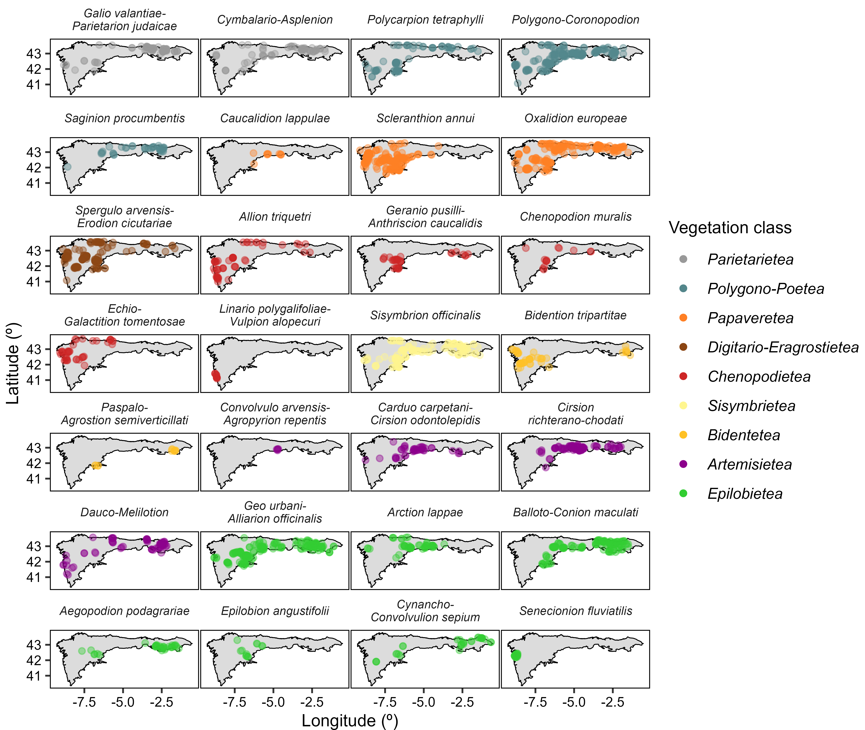

Figure 1: Anthropogenic vegetation alliances of the Iberian Atlantic ecoregion. Each dot is a vegetation plot. Dot colors indicate the vegetation class.

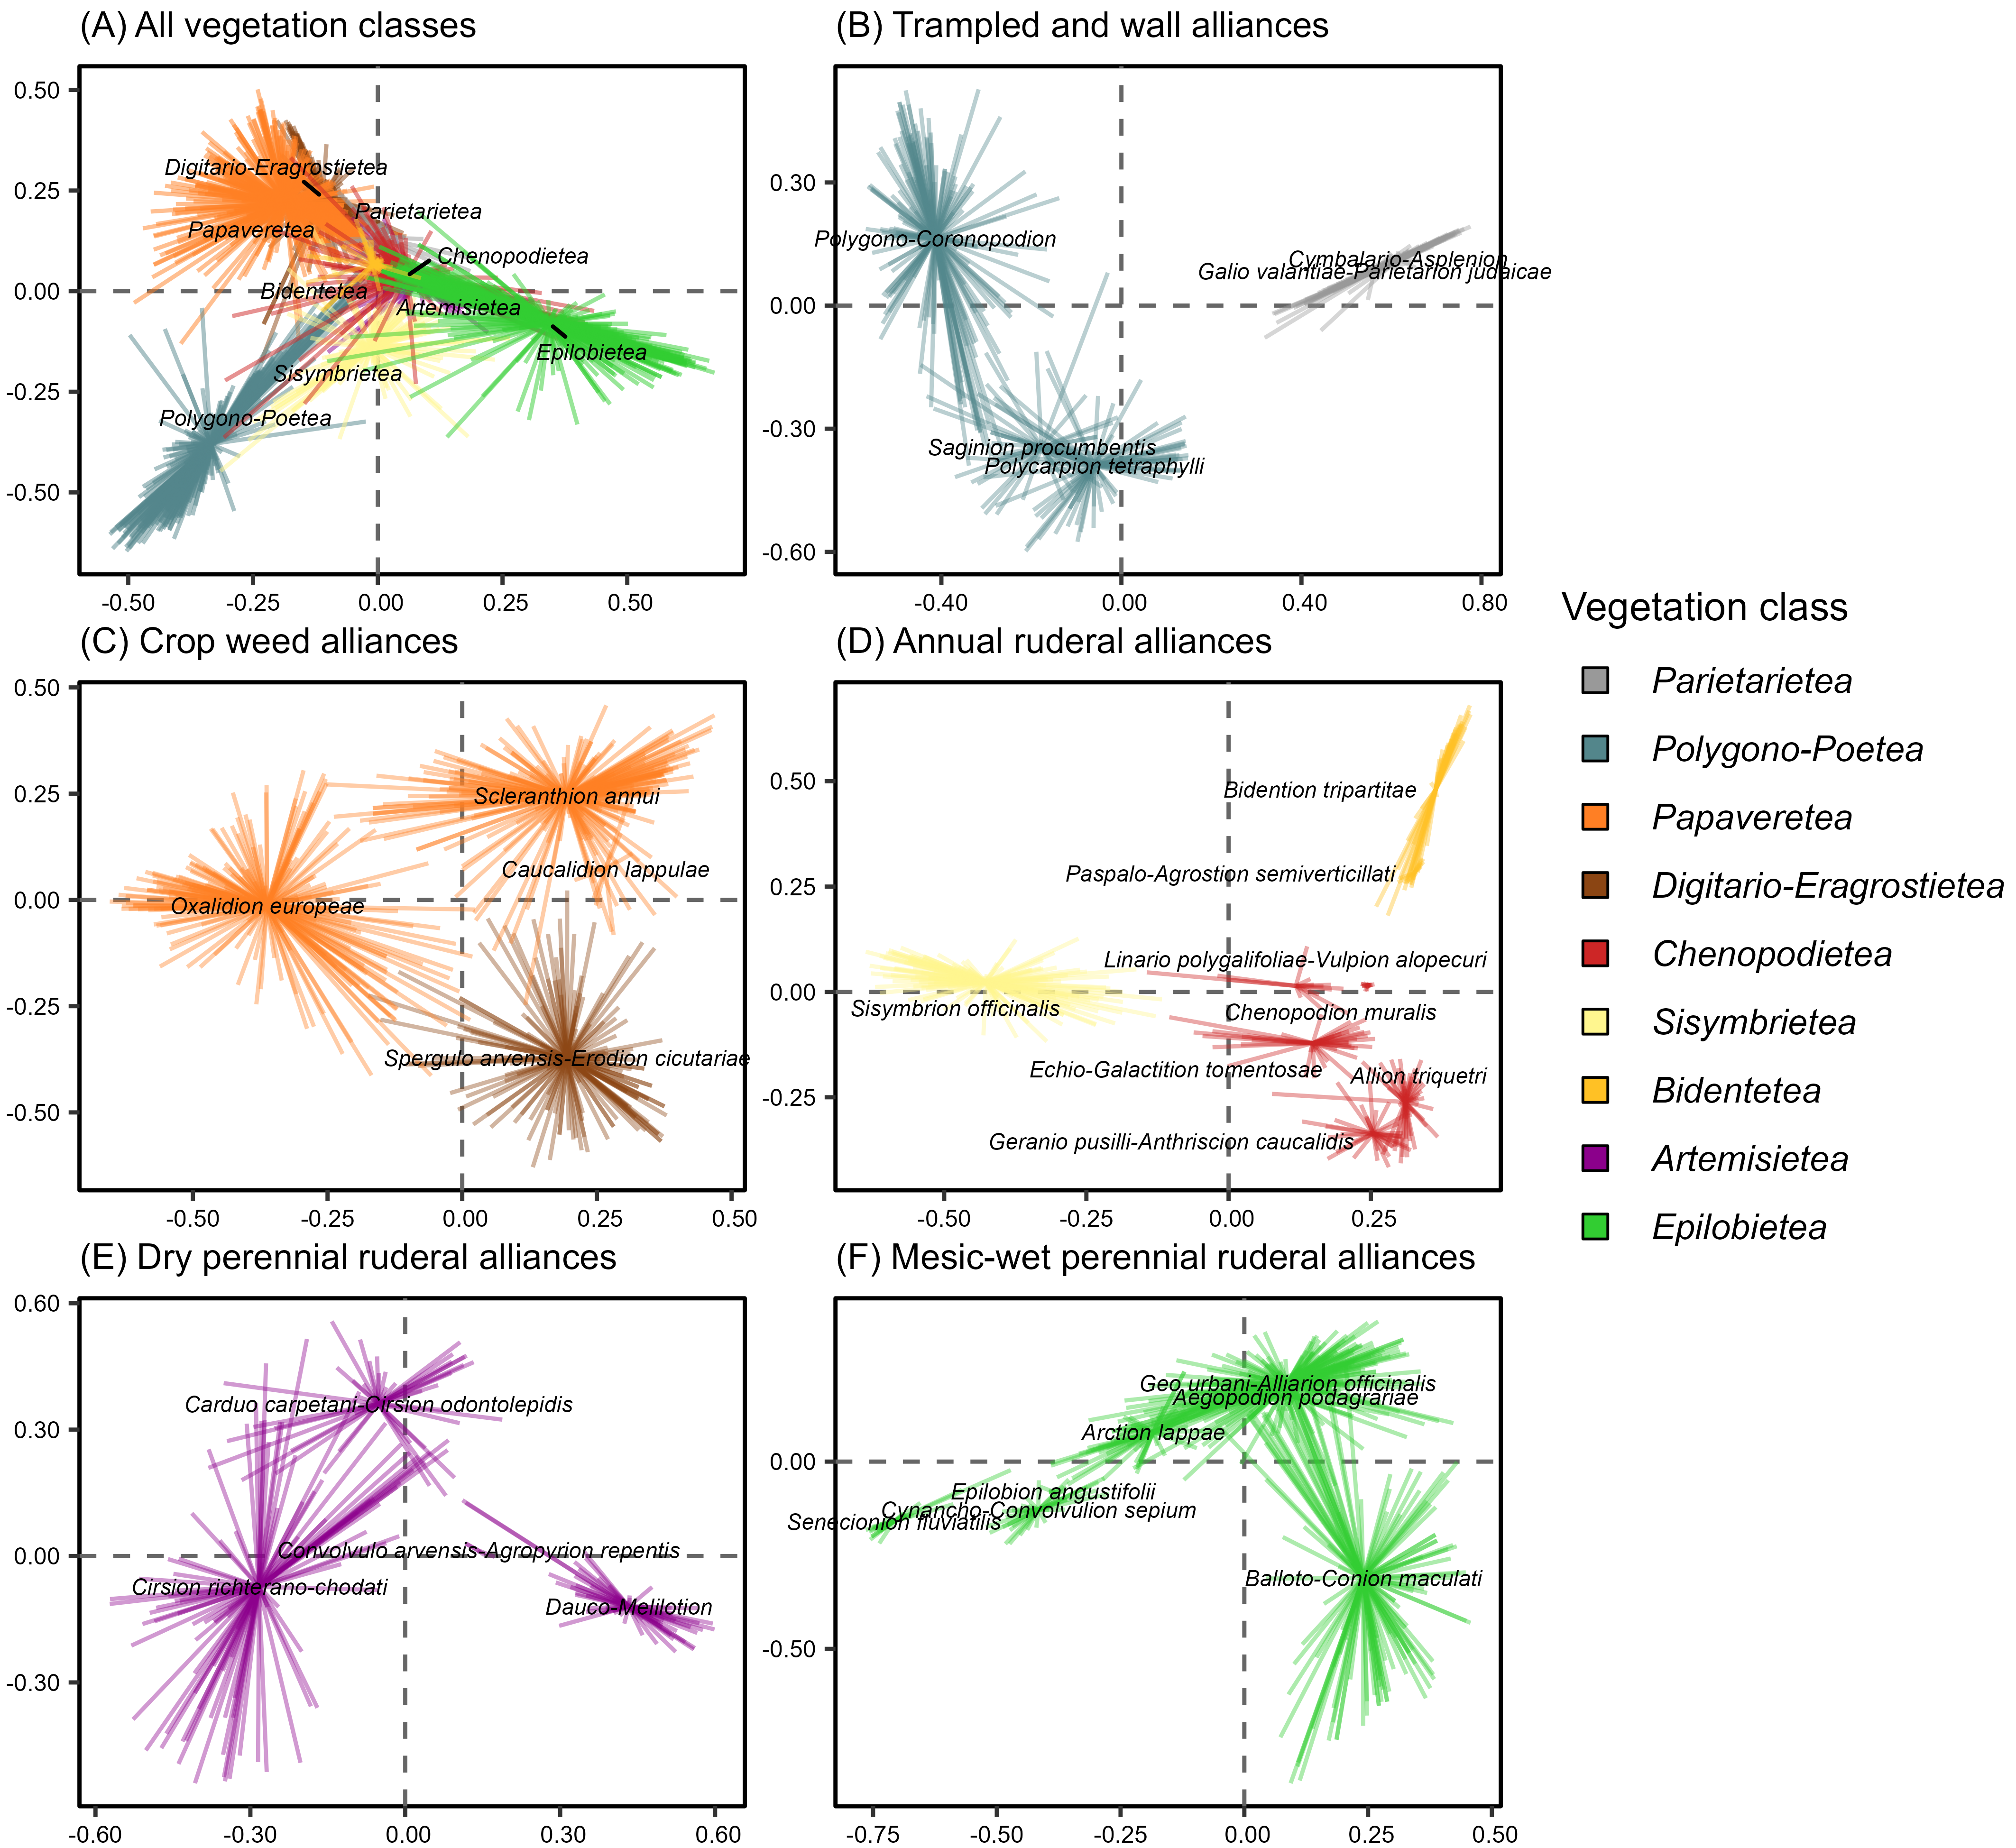

Figure 2: Floristic diversity of the anthropogenic plant communities of the Iberian Atlantic ecoregion. Biplots produced by Principal Component Analysis (PCA) with Hellinger transformation. PCAs were conducted for the whole vegetation (A) and for specific subsets (B-F). Colors indicate the vegetation class.

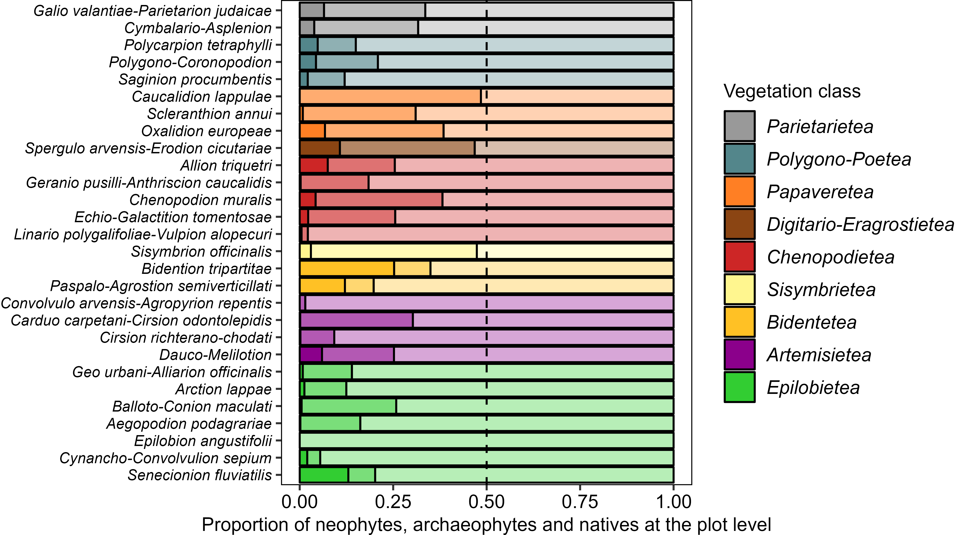

Figure 3: Proportion of neophytes, archaeophytes, and native species in the anthropogenic plant communities of the Iberian Atlantic ecoregion. Each bar represents the plot-level average proportion of neophytes (dark shade), archaeophytes (medium shade), and natives (light shade) in each vegetation alliance. Colors indicate the vegetation class.

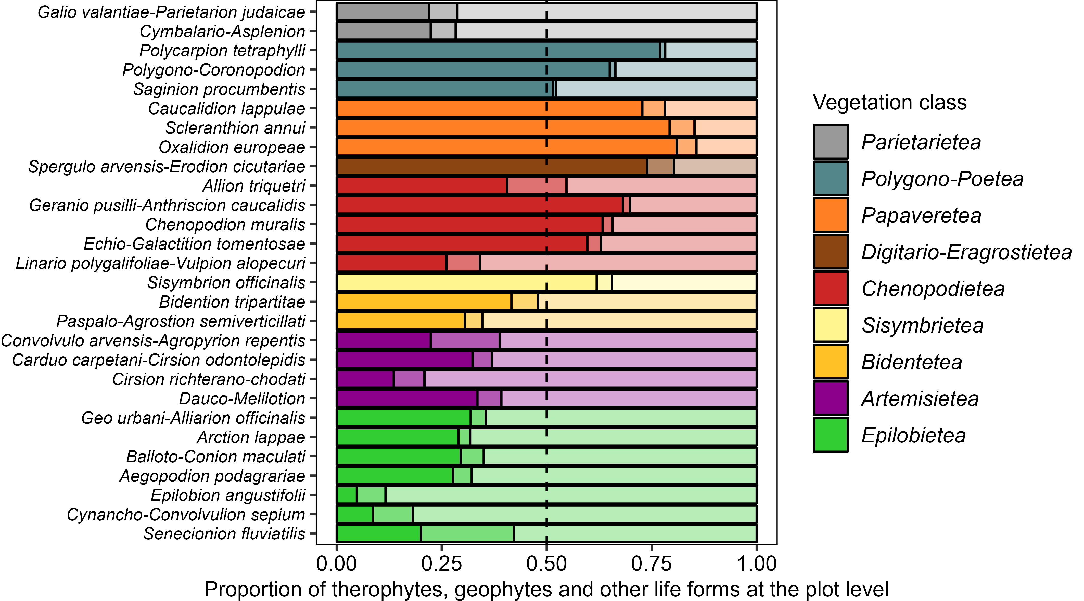

Figure 4: Proportion of therophytes, geophytes, and other life forms (hemicryptophytes, chamaephytes, phanerophytes, bryophytes, hydrophytes) in the anthropogenic plant communities of the Iberian Atlantic ecoregion. Each bar represents the plot-level average proportion of therophytes (dark shade), geophytes (medium shade), and other life forms (light shade) in each vegetation alliance. Colors indicate the vegetation class.

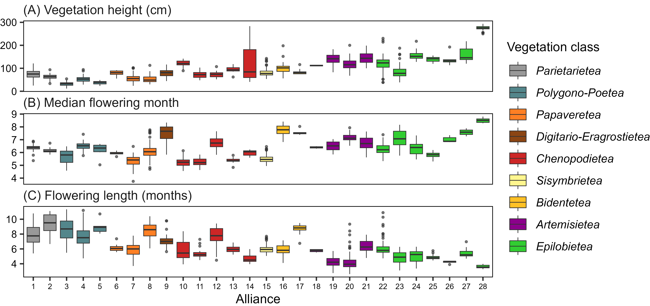

Figure 5: Vegetation height and flowering phenology of the anthropogenic plant communities of the Iberian Atlantic ecoregion. Boxplots show the community-weighted mean for plant height, median month of flowering, and length of the flowering season for each vegetation alliance. Colors indicate the vegetation class. Alliances as ordered as in Figures 1 and 3-4, and alliance numbers are the same as listed in Appendix S4.

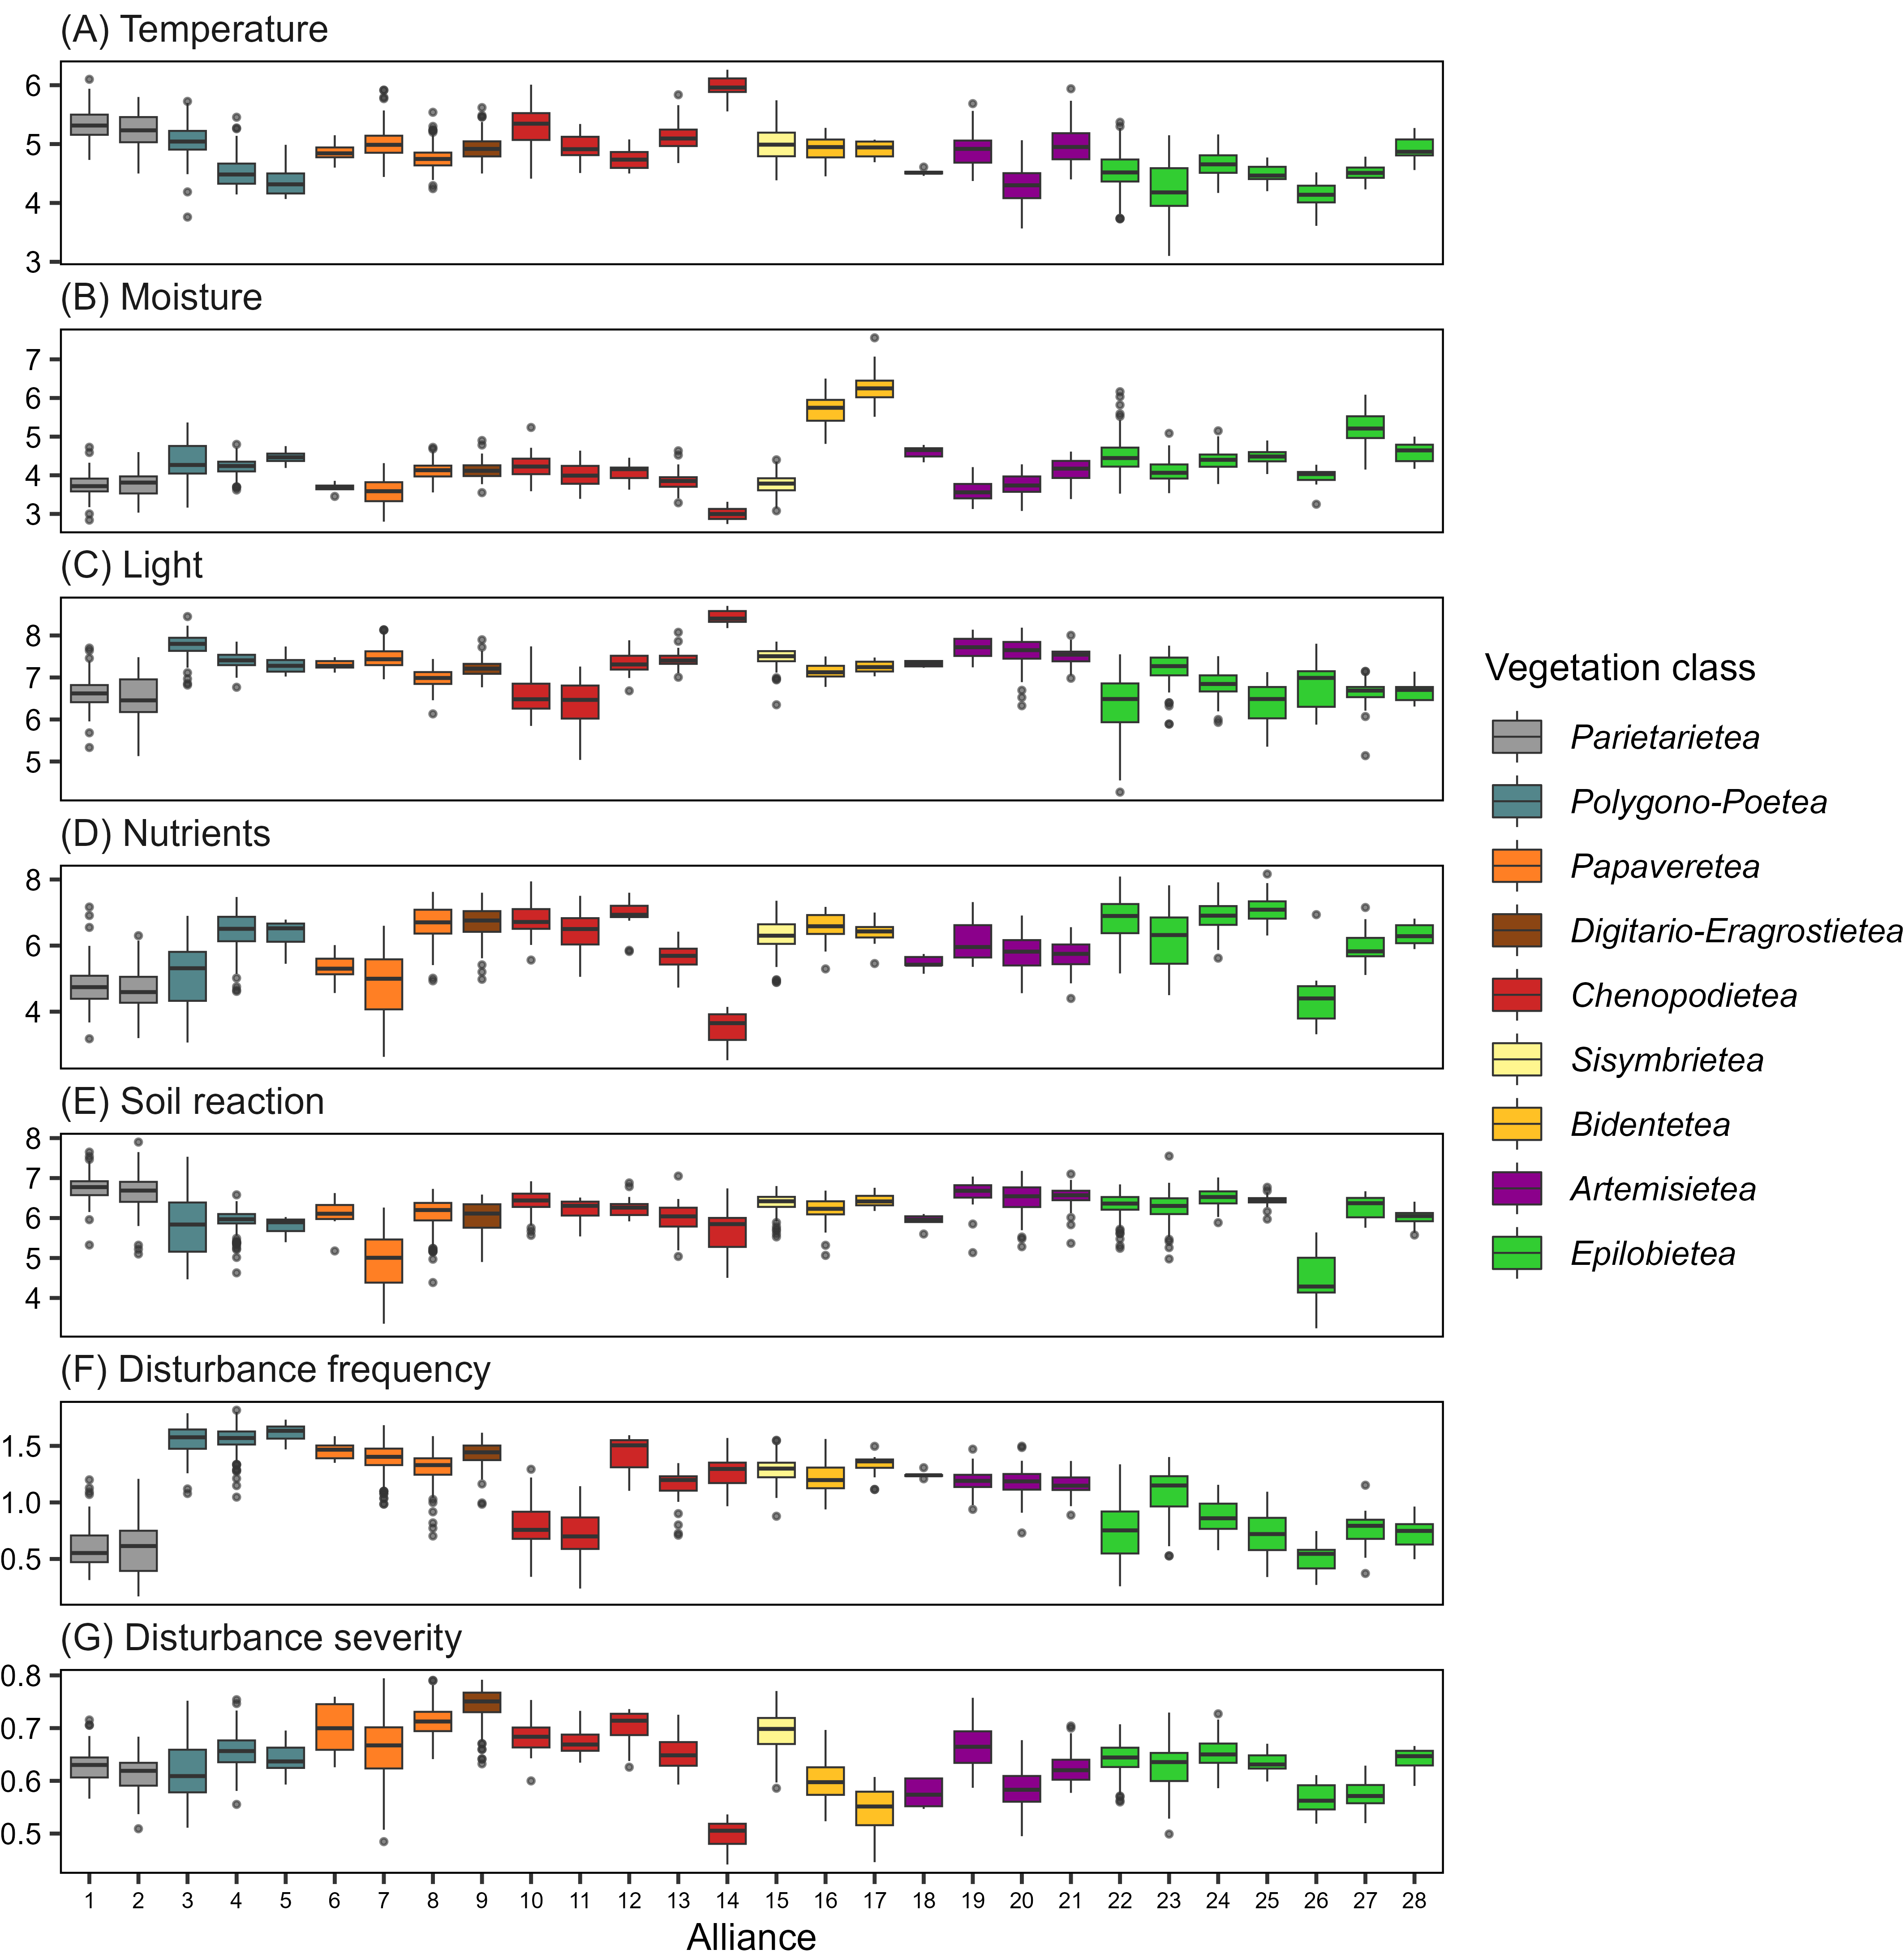

Figure 6: Ecological requirements of the anthropogenic plant communities of the Iberian Atlantic ecoregion. Boxplots show the plot-level means for the ecological indicator values of temperature, moisture, light, nutrients, soil reaction, disturbance frequency, and disturbance severity, calculated for each vegetation alliance. Colors indicate the vegetation class. Alliances as ordered as in Figures 1 and 3-4, and alliance numbers are the same as listed in Appendix S4.

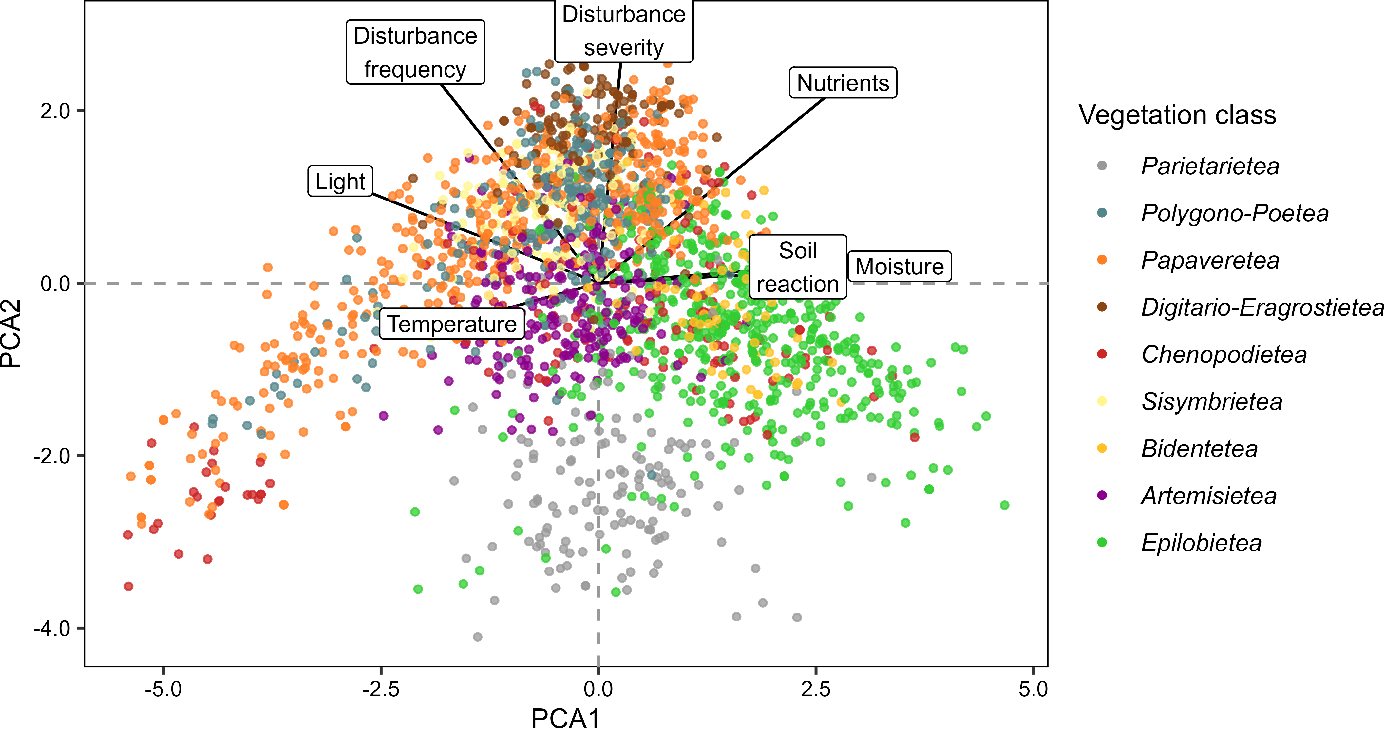

Figure 7: Ecological requirements of the anthropogenic plant communities of the Iberian Atlantic ecoregion. Biplot produced by Principal Component Analysis (PCA) of the plot-level means for the ecological indicator values of temperature, moisture, light, nutrients, soil reaction, disturbance frequency, and disturbance severity. Labels and arrows indicate the contribution of each indicator to the first and second principal components. Colors indicate the vegetation class.